Ordinary Level Questions 2017
1.
The points P and Q lie on a straight level road.
A car passes P with a speed of 12 m s⁻¹ and accelerates uniformly for 4 seconds to a speed of 24 m s⁻¹.
It then travels at a constant speed of 24 m s⁻¹ for 14 seconds.
Finally, the car decelerates uniformly to rest at Q.
The car travels 72 metres while decelerating.

Find
- the acceleration
- the deceleration
- |PQ|, the distance from P to Q
- the average speed of the car as it travels from P to Q.

(b)
A van travels from P to Q and takes the same amount of time as the car.
The van starts from rest at P and accelerates uniformly to a maximum speed of k m s⁻¹.
It then decelerates uniformly to rest at Q.
- Draw a speed-time graph of the motion of the van from P to Q.
- Find the value of k.

2.
Ship A is moving at a constant speed of 34 km h⁻¹in the direction east α° north, where tan $α$ = $\frac{8}{15}$.
Ship B is moving at a constant speed of 26 km h-1in the direction west β° south, where tan β = $\frac{12}{5}$.
Find
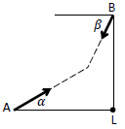
- the velocity of ship A in terms of i and j
- the velocity of ship B in terms of i and j
- the velocity of A relative to B in terms of i and j.

Ship A is positioned 520 km due west of lighthouse L when ship B is positioned 520 km due north of lighthouse L.
Ship A intercepts ship B after t hours.

Find
- the value of t
- the distance from lighthouse L to the meeting point.

3.
A particle is projected from point P, as shown in the diagram, with initial speed 40√3 m s⁻¹ at an angle of 60° to the horizontal.
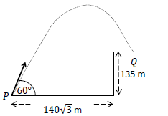
Find
- the initial velocity of the particle in terms of i and j.
- the velocity of the particle after 4 seconds of motion in terms of i and j.
- the greatest height of the particle.

The particle lands at point Q, which is on a vertical cliff of height 135 m.
The distance from P to the foot of the cliff is 140√3 m.
Find
- the time taken to travel from P to Q
- the time for which the particle is vertically above the cliff.

4.
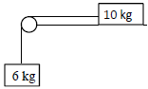
A particle of mass 10 kg is connected to another particle of mass 6 kg by a taut light inelastic string which passes over a smooth light pulley at the edge of a rough horizontal table.
The coefficient of friction, µ, between the 10 kg mass and the table is $\frac{2}{5}$ .
The system is released from rest.
- Show on separate diagrams the forces acting on each particle.
- Find the common acceleration of the particles.
- Find the tension in the string.
- Comment on the motion of the system if µ ≥ $\frac{3}{5}$.

(b)
Masses of 5 kg and 3 kg are connected by a taut light inelastic string which passes over a light smooth pulley, as shown in the diagram.
The 5 kg mass lies on a smooth plane inclined at α° to the horizontal, where tan α = $\frac{4}{3}$.
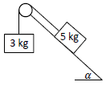
The 3 kg mass hangs vertically.
The system is released from rest.
Find
- the common acceleration of the masses
- the tension in the string.

5.
(a)
A smooth sphere A, of mass 1 kg, collides with another smooth sphere B, of mass 3 kg, on a smooth horizontal table.
Spheres A and B are moving towards each other with a speed of 5 m s⁻¹.
The coefficient of restitution for the collision is $\frac{3}{5}$ .
Find
- the speeds of A and B immediately after the collision
- the loss of kinetic energy due to the collision
- the magnitude of the impulse imparted to B due to the collision.

(b)
A ball is fired vertically upward in a room with a smooth horizontal floor and a smooth horizontal ceiling.
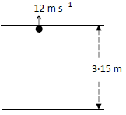
The height of the room is 3.15 metres.
The ball strikes the ceiling with a vertical speed of 12 m s⁻¹.
The coefficient of restitution for all collisions between the ball and the ceiling and between the ball and the floor is $\frac{3}{4}$.
- Find the speed of the ball immediately after striking the ceiling.
- Investigate whether the ball strikes the ceiling again after rebounding from the floor.

6.
(a)
Particles of weight 7 N, 1 N, 6 N, and p N are placed at the points (5, p), (−3, p), (p, q), and (10, 7) respectively.
The co-ordinates of the centre of gravity of the system are (4, q).
Find
- the value of p
- the value of q.

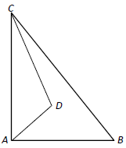
(b)
A triangular lamina with vertices A, B, and C has the triangular portion with vertices
A, D, and C removed.
The co-ordinates of the points are A(0, 0), B(12, 0), C(0, 15), and D(6, 6).
Find the co-ordinates of the centre of gravity of the remaining lamina.

7.
(a)
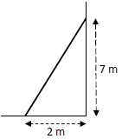
A uniform ladder, of weight 210 N, rests on rough horizontal ground and leans against a smooth vertical wall.
The foot of the ladder is 2 m from the wall and the top of the ladder is 7 m above the ground.
The ladder is in equilibrium and is on the point of slipping.
Find the coefficient of friction between the ladder and the ground.

(b)
Two light inelastic strings are tied to a particle of weight 123 N.
The lengths of the strings are 40 cm and 9 cm, respectively.
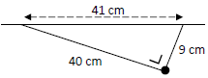
The other ends of the strings are tied to two points 41 cm apart on a horizontal ceiling.
- Show on a diagram the forces acting on the particle.
- Write down the two equations that arise from resolving these forces horizontally and vertically.
- Solve these equations to find the tension in each of the strings.

8.
(a)
A particle describes a horizontal circle of radius 0·5 metres with uniform angular velocity 3 radians per second. The mass of the particle is 2 kg.
Find
- the speed of the particle
- the acceleration of the particle
- the horizontal force on the particle
- the time taken by the particle to complete nine revolutions.

(b)
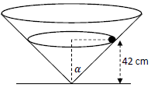
A right circular hollow cone is fixed to a horizontal surface.
Its semi-vertical angle is α° where $\tan{α}=\frac{20}{21}$.
A smooth particle of mass 2 kg describes a horizontal circle of radius r cm on the smooth inside surface of the cone.
The plane of the circular motion is 42 cm above the horizontal surface.
- Find the value of r.
- Show on a diagram all the forces acting on the particle.
- Find the reaction force between the particle and the surface of the cone.
- Calculate the speed of the particle.

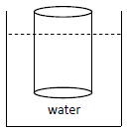
9.
(a)
A right circular solid cylinder floats at rest in water with its axis vertical.
The cylinder has a radius of 6 cm and height 20 cm.
60% of the cylinder lies below the surface of the water.
Find the weight of the cylinder.
[Density of water = 1000 kg m⁻³]

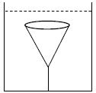
(b)
A right circular solid cone has a base of radius 6 cm and a vertical height of 15 cm.
The relative density of the cone is 0·8 and it is completely immersed in a liquid of relative density 1·4.
The cone is held at rest by a light inelastic vertical string which is attached to the base of the tank.
The upper surface of the cone is horizontal.
Find the tension in the string.

